ICA

What Is Preprocessing?

In general, preprocessing is the procedure of transforming raw data into a format that is more suitable for further analysis and interpretable for the user. In the case of EEG data, preprocessing usually refers to removing noise from the data to get closer to the true neural signals.

1.1. Why is preprocessing needed?

There are several reasons why preprocessing is necessary for EEG data. First of all, the signals that are picked up from the scalp are not necessarily an accurate representation of the signals originating from the brain, as the spatial information gets lost. Secondly, EEG data tends to contain a lot of noise which can obscure weaker EEG signals. Artifacts such as blinking or muscle movement can contaminate the data and distort the picture. Finally, we want to separate the relevant neural signals from random neural activity that occurs during EEG recordings.

Several Questions:

Ques-1What kinds of artifacts might be present in your data? Which ones do you want to remove, and which ones do you want to flag to be aware of?

Ques-2Which features do you want to focus on?

FIF : Functional Imaging file format

Removing Bad Channels and Interpolation:

After removing Bad channels we have to interpolate the data:

3.1. What is a ‘bad’ channel?

Sometimes EEG data (especially high-density EEG data) will contain ‘bad’ channels that do not provide accurate information. It is important to remove those from analysis early on because keeping.

**Interpolation**

After flagging bad channels, it is common practice to interpolate data for the bad channels based on the data from the good channels. Interpolation is a way of filling in the missing data based on the other data available.

There are a few ways of interpolating EEG data, but by far the most common is interpolation by spherical splines. This method consists of the following steps:

Project the channel locations onto a unit sphere (representing the head)

Compute a matrix that describes the relationship between the good and bad electrodes

Use the result from (2) to interpolate the data for bad electrodes

Note that the decision to remove a channel post-hoc because of high noise level can be a bit arbitrary - use your experience and judgement to determine how much noise is appropriate. You should take into account that [**ICA**](http://learn.neurotechedu.com/preprocessing/#ICA) will be able to remove some of the noise without having to remove an entire channel. Once you’ve decided which channels to remove, you can mark bad channels either via an MNE command:

raw**.**info['bads'] **+=** ['names of channels to remove']

Or interactively, by clicking on the channel line or channel name in the window. The channels you clicked on will then be marked as bad once you close the window.

3.3. How to remove a bad channel from the data

Once you have identified the bad channels, you can exclude them from further analysis by picking a subset of channels that excludes the ones marked as ‘bad’:

picks **=** mne**.**pick_types(raw**.**info, exclude**=**'bads')

Now when you do further analysis, you can set picks as the channels that will be analysed. For example, if you want to split the data into epochs,

epochs **=** mne**.**Epochs(raw, events, event_id, tmin, tmax, picks**=**picks,

baseline**=**(None, 0), reject**=**reject, preload**=**False)

will have the bad channels excluded since picks does not contain bad channels.

Note that if you have a lot of bad channels, or if you don’t have many channels to begin with, simply removing bad channels will result in a significant loss of information. In those case, you might want to repair or interpolate the excluded channels instead.

## **Filtering**

When looking at the frequencies of a digital signal, whether it be audio, EEG, or otherwise, a popular thing to do is to filter certain frequencies, such that either some frequencies are removed, or possibly that some filters remain. There are a number of types of filters:

* Low-pass filter: ‘Low’ frequencies below a certain value are kept (they ‘pass’), while high frequencies are removed. This is also known as a high-cut filter. It may help to think of the audio version of this, which would be something that removed all the high notes from a sound.
* High-pass filter (a.k.a Low-cut): The same as above, but only high frequencies remain, and only those below a certain value are removed.
* Band-pass filter: Combining the two, this keeps only frequencies between a lower and upper bound. The opposite is a band-cut filter, which removes all frequencies in a particular range.
* Notch filter: This is a special type of band-cut filter, that removes a single frequency. It is also possible to combine multiple notch filters, to remove a particular set of single frequencies, useful for things like removing electricity noise.
* *Removing electricity noise:* generally the electrical circuits surrounding your measurement will introduce noise in the 50Hz or 60Hz range (plus multiples).   
  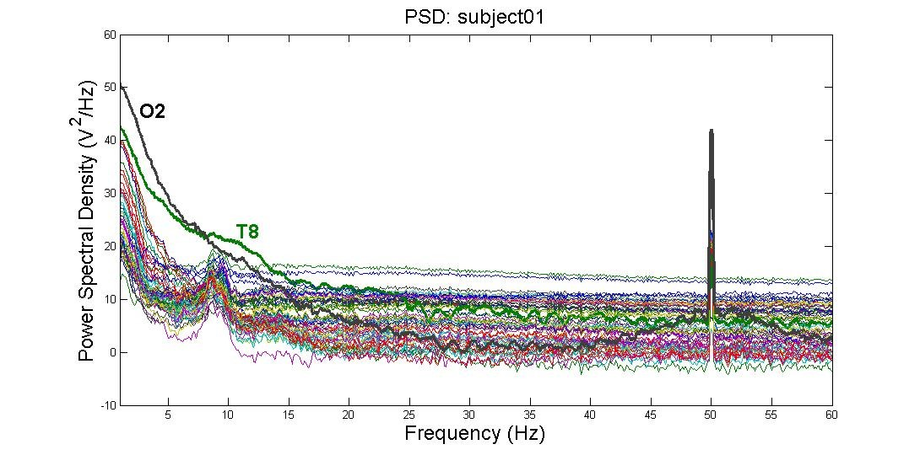   
  This image (from [**http://blricrex.hypotheses.org/ressources/eeg/pre-processing-for-erps**](http://blricrex.hypotheses.org/ressources/eeg/pre-processing-for-erps) [**(11)**](http://learn.neurotechedu.com/preprocessing/#references)) shows clearly some 50Hz noise from electricity (note that some countries, like USA, use 60Hz). To remove these, a notch filter can be performed on the raw signal with MNE to remove 50Hz and its multiples.

raw**.**notch_filter(np**.**arange(50, 251, 50))

* Often you only care about a certain frequency range - e.g. if looking at alpha waves, only the 7.5Hz - 12.5Hz range is needed, so it can be useful to perform a band-pass filter between these values to remove any noise outside that range:

mne**.**filter**.**filter_data(raw, sFreq, l_freq**=**7.5, h_freq**=**12.5)

* High-pass filtering can be added to remove very low frequency signals. These are too slow to originate from the brain, and are usually a sign of long-term drift in the recording environment.

Care needs to be taken when performing any filtering however, to ensure that it introduces no extra source of error. For more details on where potential pitfalls have been found, see the [**MNE documentation**](https://martinos.org/mne/stable/auto_tutorials/plot_background_filtering.html#some-pitfalls-of-filtering) [**(12)**](http://learn.neurotechedu.com/preprocessing/#references) on filtering issues. Additionally, if you’re interested at how these work, or want to know the difference between the method='fir' (default) and method='iir' options, see the video [**Overview of FIR and IIR Filters**](https://www.youtube.com/watch?v=9yNQBWKRSs4).

DownSampling: Reduce the sampling rate.

INTRODUCTION:

EEG reocords cerebral activity and electrical activites from sites other than brain.

Anything that is NOT cerebral activity is called Artifact

Types of Artifcact:

1. Pysiological artifact: Generated other than brain.

2. Extrapysiological artifact: Generated outside the body.

Key to keep artifact free recording:

* Good ,clean prep
* Balanced impdences
* Good hook up , neatly bundled electrodes.
* Place jack box close to Patients head
* Keep patient cool , not cold
* Unplug all electrical items closed to patient i.e. bed , ratio, fan etc.

